Therese Morris



Former Social Media Manager for TouchMedia (Flagship SociaLingua)

September – October 2010

NB. The SociaLingua blog has since been thoroughly revamped and currently only display articles posted after January 18, 2011 therefore links to articles provided below are no longer valid.

http://blog.socialingua.com/2010/09/the-mountain-the-music-and-the-mystic/
31 likes
Sep 27 / therese

The Mountain, the Music and the Mystic

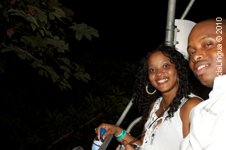

I had not given any thought to the details of the invitation from Mystic Mountain’s Maxine Gawron and MSW Planners’ Monique Walcott as they iterated and re-iterated that “guests will be lifted to the top of the mountain” and even signing the waiver had not sparked any clues as to what I was in for.
Along our brief walk to through a vegetation-filled footpath, the babbling of the nearby river was a sweet accompaniment that continued as we navigated the bridge crossing the river. On the other side, footprints on the pavement guided us to the point where we would catch the next chair to the mountain.
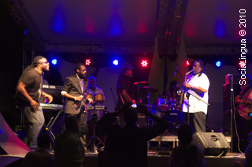
From there, our “lift” began, with the town of Ocho Rios seemingly unfurled like a glistening carpet from under the moonlit rainforest. The ride, billed as a 15-minute trip, seemed far longer especially for those fearful of heights. Rattled nerves and white-knuckle grips contrasted with the expanded vistas and with the pulls and bumps as the chair scaled the slope.
At the top, dismounting proved a bit tricky as the chairs do not actually stop in their cycle. Nonetheless, we got there in time to see Tarrus Riley performing on a grand stage branded with Digicel’s 4G Broadband promo material, with mainstay and musical director Dean Fraser on saxophone and backup singers.
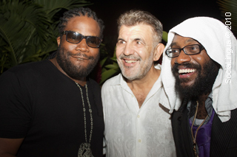
Tarrus was eventually joined on stage by Gramps Morgan, of Morgan Heritage fame, for his second round of performance; they had a friendly face-off on soul and reggae classics. Dean Fraser chipped in with his sax, to the great delight of the audience.
Mystic Mountain principal and the night’s emcee, Michael Drakulich, introduced Jimmy Riley, father of Tarrus Riley, to the stage. Father and son then proceeded to run through the elder Riley’s hefty catalogue, Jimmy’s knowing rasp nicely complimented by Tarrus’ youthful but no less soulful crooning.
As part of the evening’s entertainment (and, no doubt, of the property’s branding efforts), patrons were treated to a rainforest bobsled ride, and DJ Arif ‘SupaCoop’ Cooper closed the night out with reggae and dancehall mixes.
Among those spotted enjoying the ‘natural mystic’ were FAME-FM’s Francois, Stephanie Scott from Restaurant Week, and PJ Wright from Wright Image
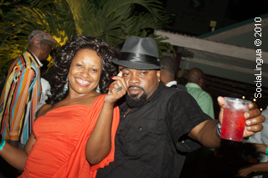
It might have seemed that getting down would be more nerve-racking than going up, but we were better prepared for the chair lift down the mountain. On our descent, the concern of other patrons in the chairs behind us was audible proof that it was still not a “walk in the park”.
The event, the first of four planned through December, was sponsored by Digicel 4G Broadband, WISYNCO, Coca-Cola, Ocean Spray, WATA, Base Kingston, Essence Ultra, MSW Events, Sparkles Production, Red Bull and Johnny Walker.
The next in the series takes place October 23, with subsequent outings on November 27th and December 18th.
Filed under Events
0

http://blog.socialingua.com/2010/09/speak-easy-heathers/
12 likes
Sep 18 / therese

Speak Easy @ Heather’s
SAM “DA MAN” TO THE RESCUE

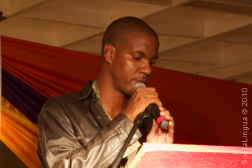
There will likely be no high praise or accolades for Samuel Gordon; when national honours are being given out, there’s little chance that his name will even enter the minds of such committees.
And that will be a shame, because on the strength of his reading at the latest edition of Speak Easy – the poetry/art display/creative gathering on Wednesday nights at Heather’s in New Kingston – Gordon certainly deserves that kind of consideration. He was easily the best performer on the night.
But then again, maybe the bullets of social commentary and the heartfelt yet unsentimental reflections that peppered his eloquent monotone either cut too close to home or otherwise offer no easily digestible impressions or obvious sing-song rhyme patterns for the audience to lap up.
Instead, he served up potent reminders of the divisions that continue to hold the society back, as well as intriguing bits of hard-won experience (“Devil”). Even the seemingly breezy “Things That Make Me Smile” had a knife’s edge under the mostly upbeat one-liners.
Elsewhere on the roster, the always colourful Ganja Ganjari delivered a mixed set (two of his own works, combined with one each from two poets he admires), with somewhat mixed results. There was also a case of reach exceeding grasp, as a young man, who had the admirable gall to bill himself as “The Magnificent One” failed to live up to those lofty expectations, and this on his “first performance anywhere.”

There was some welcome musical levity, as Black Zebra lead guitarist Wayne McGregor laid down a tight but engaging solo acoustic stint, beginning with the Willie Dixon-Muddy Waters’ classic “Hoochie Coochie Man” and ending with “Main-tenance Song”, a humourous parody of Bob Marley’s “Redemption Song”. He earned the night’s only encore and obliged with a classic from the 80s.
Those highlights aside, the only mentionables were largely “un-mentionables” as Marie Scully and later Zahara demonstrated that women could be every bit as lascivious and sexually forward as men could, a development which the males in the audience were only too eager to accept.
Even with the uneven quality of the offerings, the showcase is a more than welcome addition to the live event calendar and, along with the recently activated Thursday Night Live show, gives Heather’s solid one-two punch in an otherwise mostly quiet mid-week period (notwithstanding Fiction’s Brand New Machine series and others).
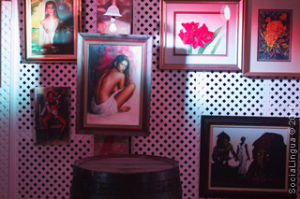
Here’s hoping we’ll encounter more people like Sam as it goes along.
Filed under Events
0

http://blog.socialingua.com/2010/09/sound-of-the-new-legends/
32 likes
Sep 17 / therese

Sound of the New Legends

Even some three decades after his passing the shouts of those, home and abroad, seeking the “next Gong” or the “next Bob Marley” can be deafening at times.
On Sunday night last, at the place the Gong made famous, a number of artists set about building their own legends, and went a far way towards quieting those calls, as they made some vital noise of their own.
The back courtyard of the Bob Marley Museum complex at 56 Hope Road was an amiable scene, the area going from sparse early-birds to a sizeable and diverse mass of music lovers by the time the emcee called the event to order with a rousing invocation, “livicated” to the spirit of those who have passed on and marked by loud whoops and the calling of names from among the audience.
Another lull ensued thereafter and this writer used the opportunity to peruse the displays on hand (from the community arts group MANIFESTO JA) and others before heading to another event.
We returned in time to catch C-Sharp, with lead singer Chevaughn “Holiday” Clayton in full flight, his band mates adding thick, percolating grooves in support. With an unforced, yet obvious intensity, they blasted through new material (“Nurse” from their forthcoming album) as well as previous favourites like “What’s The Matter With the World”. Clayton along with bassist Aeion Hoilett, guitar maestro Lamont Savory, Dwain Campbell on keyboard and percussionist Randevon Patrick are among the unheralded heroes of Jamaican music – and that situation needs to change.
The same goes for the balance of the line-up, notably Jah9, who can move effortlessly between sultry yet open-eyed love songs to the pinpoint lyrical commentary of “Warning”, and Fyah Blaze, who is taking no prisoners with his Truths and Rights CD.
While there, we caught up briefly with director Storm Saulter, whose debut full-length feature, Better Mus’ Come, opens on local screens come October 13.
All considered, a satisfying evening of art and entertainment – with no Marley comparisons warranted. These are the legends of Now. Hear them well.
Filed under Announcements
0

http://blog.socialingua.com/2010/09/from-the-deck-to-the-skyy/
346 likes
Sep 7 / therese

From the Deck to the Skyy

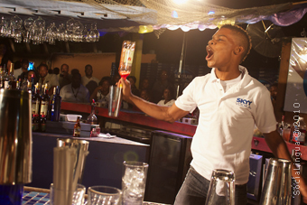
In a flurry of flying bottles, slick twists and turns and an engaging smile, bartender Albert Brown made the National Finals of the Skyy Vodka Flairtending Challenge under the net-fringed canopy of prime Kingston watering hole, The Deck last Tuesday night.
With Zipjock Bambino pacing the proceedings, two-time champion Brown, of the hip franchise eatery TGIF, clearly stamped his class on the tournament. He juggled as many as four bottles, twirled them around his shoulders and did amazing back passes, making it all look as easy as pouring vodka and O.J. eliciting wild cheers from the sizeable crowd.
For his efforts, he secured an all-expense paid trip to St Lucia, where he will compete with his counterparts from around the Caribbean, all hoping to cop the coveted spot in the World Finals, set for Barcelona, Spain in October.
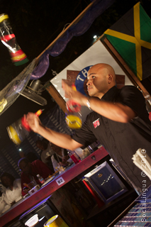
Second place went to Kimalie Robinson, the lone rep from Montego Bay, with Brown’s colleagues, Samir Lovejoy and Kevin Stewart rounding out the slate. The contestants were judged by Lisa Bell of Lascelles (Jamaican representatives of the Skyy brand); Patrice McHugh of BarsToGo and dancehall’s “certified Diva” Tifa. Hans Crosby, Trinidadian performance bartender and founder of the League of Extraordinary Bartenders, was also on hand to help guide the “flairtenders” in their quest to be the best.
Assessing the Jamaican experience, Crosby had high praise for the charges, declaring them energetic, eager to perform, learn and do well, mixed with a powerful patriotic nature.
Of the standard, he said “I was pleasantly surprised to be honest. I was afraid that the following for flair bartending in Kingston could only be found within TGI Friday’s and ‘kids’ between the ages of 18-25, but people of all ages attended and enjoyed the event.”
For her part, Lisa Bell also praised the contestants, reminding that the exhibition of skill was not as easy as it looked. “This takes a lot of practice and dedication. The competition is very tough, but the guys have all worked very hard with Hans, and we’re confident of a good showing at the next level.”
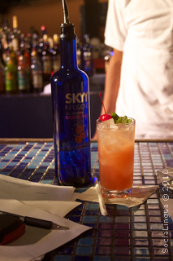
“This means a lot to me, to again have the chance to represent Jamaica,” Brown said, adding that he was grateful for the support from friends as well as from the Skyy Vodka team.
With the competition over, the crowd hung around soaking up the music, the vibes and, of course, the vodka!
Filed under Announcements, Events
7

7 Comments
leave a comment
- michael / Sep 8 2010

who wrote this this writer is mhaaad makes me feel like i should have been there!!!!
reply
- chokmah / Sep 8 2010
I was led to this article by this tweet: : Over a 150 Facebook Likes on our “From the Deck to the Skyy” blog on the SociaLingua WaterCooler see why . Its the “see why” part that intrigued me and clicked on the link.
Very, very, very impressed (did I say very?) with how the article was written…very engaging and with the right tone..actually enjoyed reading it for the writing itself.
Good stuff!!
reply
- Ed Mathurin / Sep 8 2010
See you’ll in St Lucia for the finals…bring it….
reply
- Emma Lewis / Sep 8 2010

How do these guys do it? As the most physically uncoordinated person on the planet, I am awestruck. From the pictures I have seen, Mr. Brown seems to be a master of juggling (and I don’t mean the musical kind), and is also having so much fun! Good luck to the young man… Great photos by the way.
reply
- Corve DaCosta / Sep 10 2010

This is impressive stuff
reply
- Jamaipanese / Sep 10 2010

wow, I want to be there!
reply
- Kenjam1 / Sep 11 2010
WOW!…SAW ALBERT BROWN ON ‘SMILE’ ON WEDNESDAY….THAT GUY IS AWESOME…GREAT STUFF…WHO CAN BEAT HIM?…GO GET THE PRIZE IN ST. LUCIA AB…….
reply

Leave a Comment
Top of Form
Name (required)
Email (required, will not be published)
Website
Comment
Comments Feed

Bottom of Form

http://blog.socialingua.com/2010/08/skky-vodka-global-flair-challenge-2010-the-event/
53 likes
Aug 31 / therese

Skky Vodka Global Flair Challenge 2010



The Event
The most talented flair bartenders from around the island will compete in the annual Skyy Vodka Global Flair Challenge 2010, National Finals, which “flairs off” on Wednesday, September 1, 2010 at Kingston’s The Deck. Participating now for the fourth year, Jamaica has topped the regional competition twice.
The Skky Legend
Since starting in San Francisco, Skyy has grown to become the leading premium vodka. As Trudy-Anne Riley of Lascelles explains, “Skyy Vodka is a super-premium brand with a very glamorous personality, and we would like to share with our consumers this super-premium experience through the art of Flairing.”
Winning the Challenge
Participants will have seven minutes to complete three Skyy Vodka Cocktails: Working Flair Drink, Exhibition Flair Drink and an Infusion Flair Drink. The Infusion Flair Drink will provide an opportunity to show their unique style and creativity using Skyy Vodka Infusion flavours. They are currently available in Citrus, Raspberry and Passion Fruit.
The Creations
With the wonderful Skyy Infusions flavours and Jamaican “flair” the possibilities are endless. Among the in-demand cocktails previously created are Bitter Passion – a heady mix of Skyy Passion; Campari; sugar syrup; mango, orange and lemon juice – along with the Island Cosmopolitan: Skyy Citrus Infusions vodka combined with cranberry and orange liqueur.

The Prize
The winner of the National Finals moves on to the Regional Finals in St. Lucia, and from there, should they advance, to the Skyy Vodka Global Flair Challenge Finals, which will be held October 2010 in Barcelona, Spain. National finalists will also train with renowned mixologist Hans Crosby. Last year’s Global Challenge winner won €7,000.
Filed under Announcements, Events

